8th experiment:

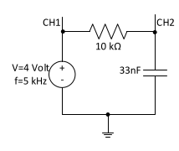
goal:
1.getting used to integrating and derivation circuits
2.input and output of these circuits
3.charge and de charge of capacitors

first part: =============
we bind the following circuit on breadboard

before all of this we turn on the function generator, we connect the function generator’s probes and test them before hand and we put the function generator on desired options; for o-scope we turn it on we test the cables beforehand and we start using it by connecting its probes to desired locations;

we apply a square wave into input;
we see the following output

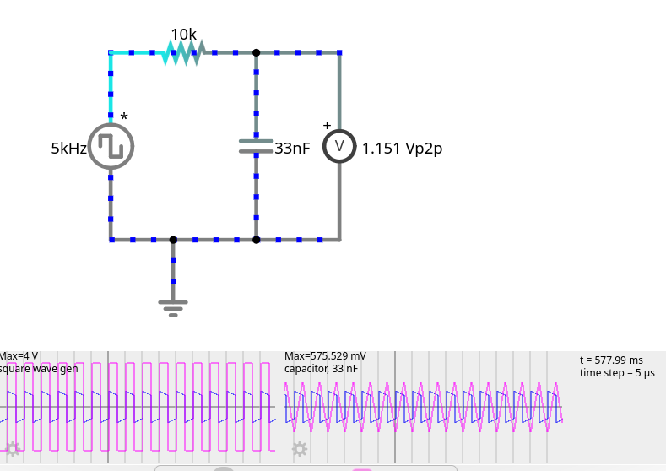

we apply a triangle wave into input;
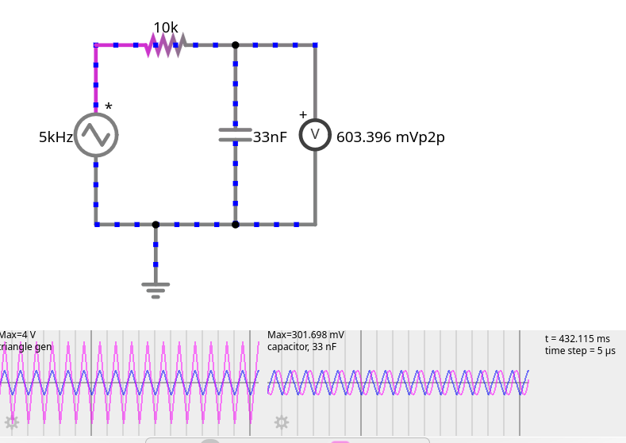
we see the following output:

whats the relation ship between input and output of these circuits?

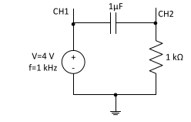

Second part:

we bind the following circuit on the board

we apply a sinus wave to the input;
we see the following output

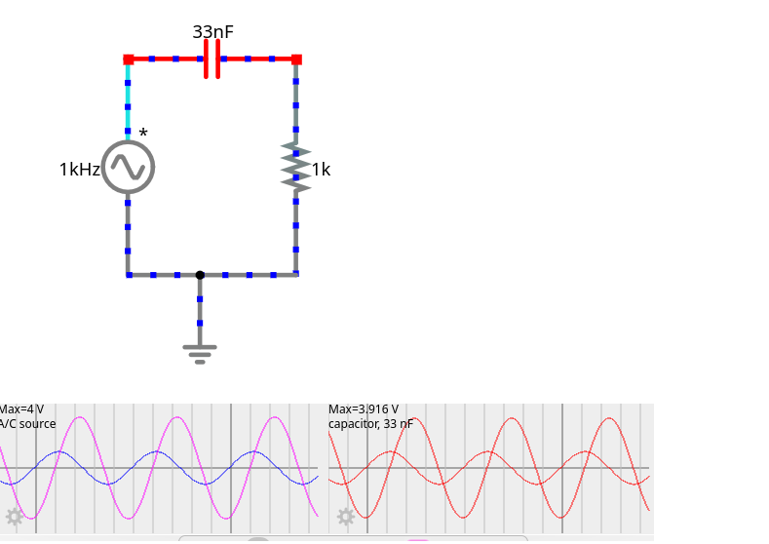

which is clearly a derievator
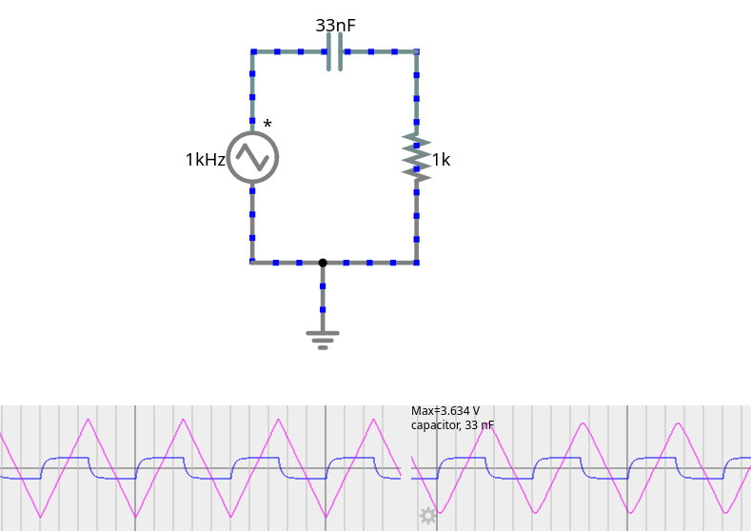
we apply triangle wave to input; and see the following output:

the relationship between input voltage and output voltage is :

third part:
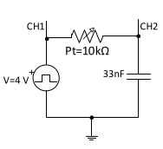
we bind the following circuit on bread board and connect one channel of o-scope to the source and the other to the capacitor

we put the pt at max and apply the voltage; we see this in the output:

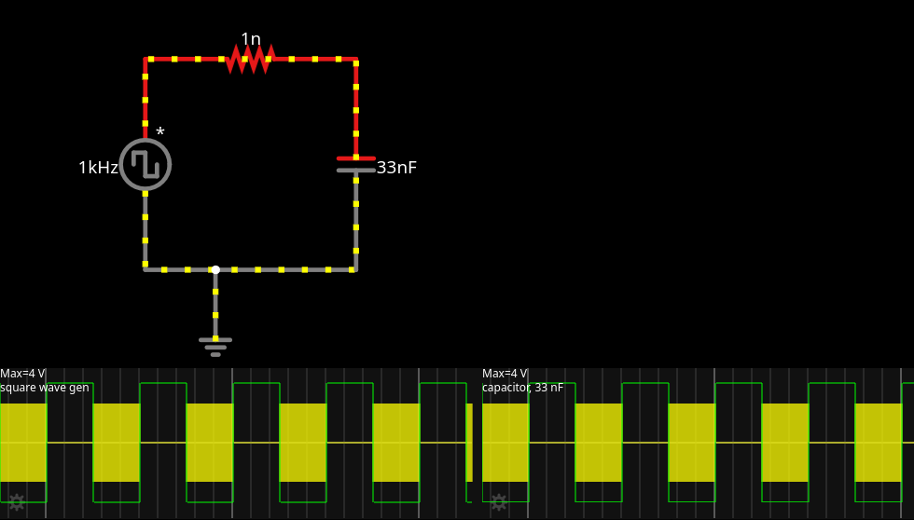

kind of a an integration

we put pt at mid:
and we see this:
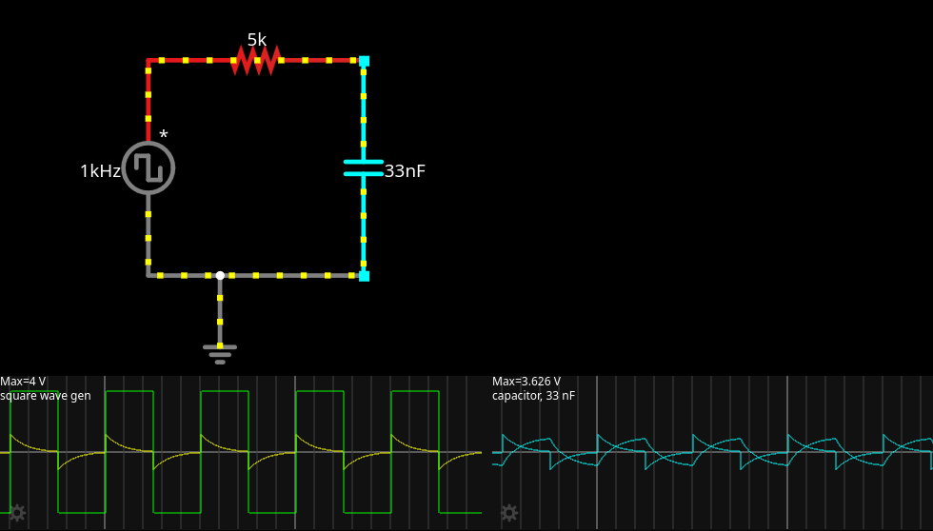

we put it at pt=max
we observer this:
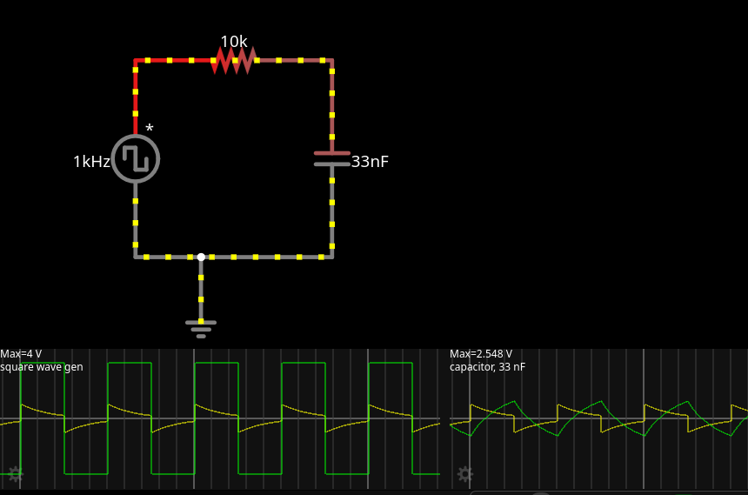

now we put it at pt=max and we sequentially put the wave gen at 100hz, 600, 2k and 5k
and we observe these:

the 100hz

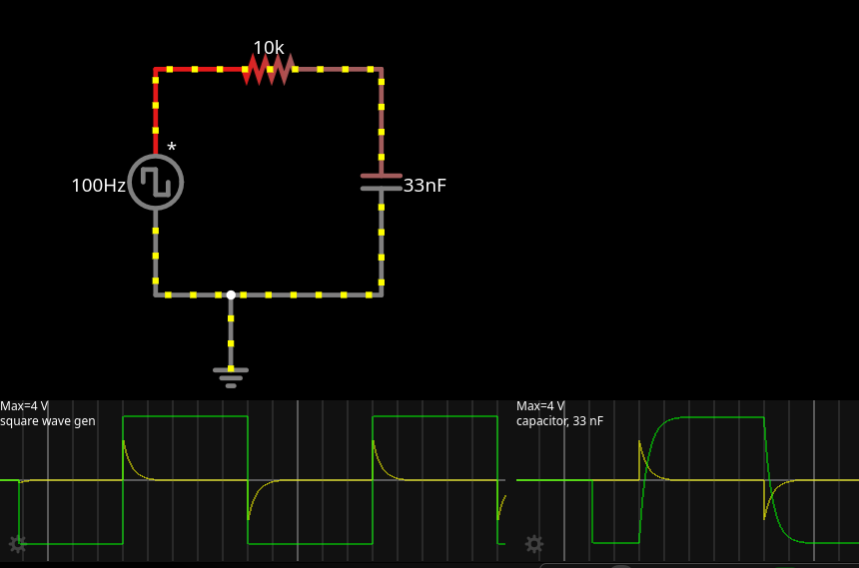
the 600hz:

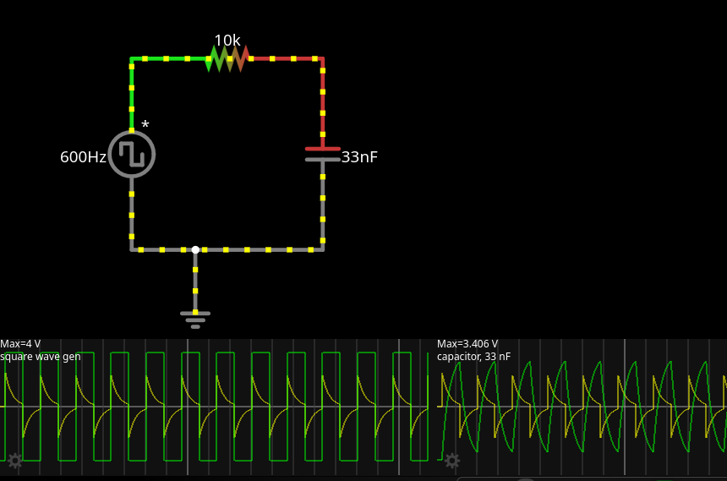
the 2k:
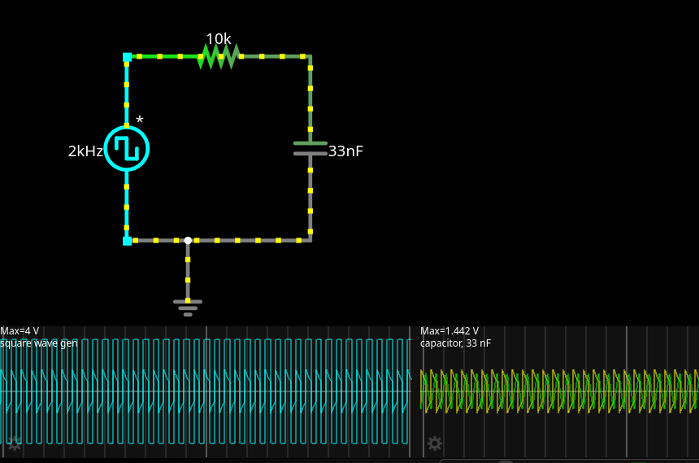
the 5khz:
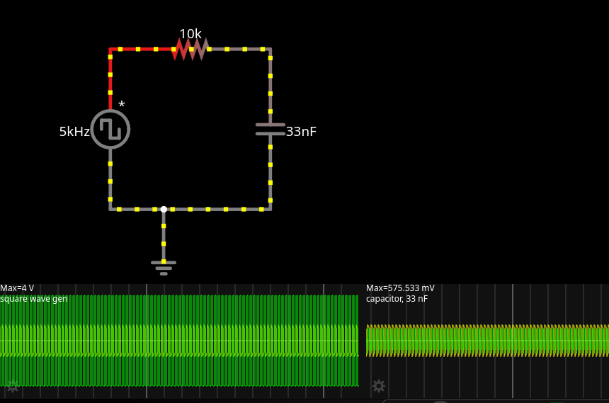

the higher the frequency of input the less charge will be stored in capacitor per each cycle;

now we put f = 100 and c = 1uf and we observer this:

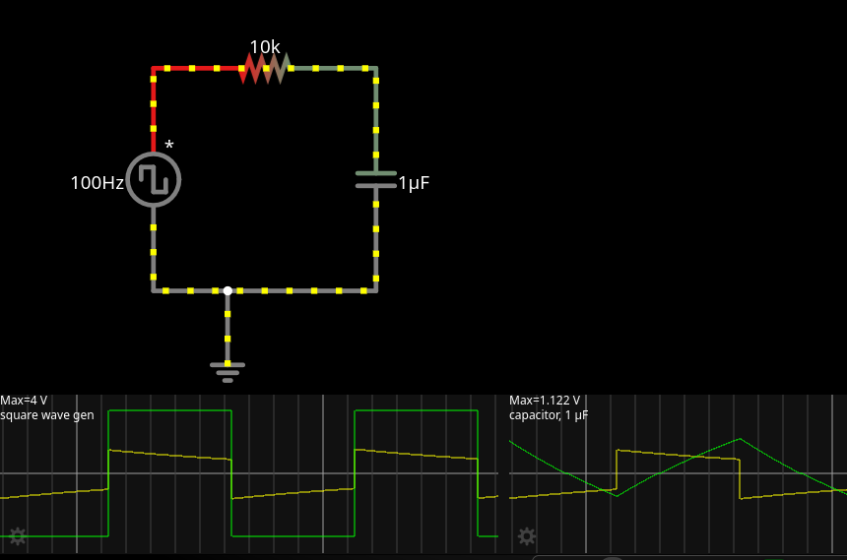

the effect of capacitor in output is
- Capacitors combined with resistors set the time constants for charging and discharging.
- Effect on square wave:
- Control the frequency and duty cycle of the waveform.
- Affect the rise and fall times, thus shaping the waveform.

for the charging and de-charging
for charging:
- There must be a potential difference (voltage) across the capacitor terminals.
- The capacitor will start charging when connected to a voltage source through a closed circuit.
- Current flows into the capacitor, causing its voltage to increase as it stores electric charge.
- Charging continues until the capacitor voltage equals the voltage of the source, at which point the current flow effectively stops.
- The charging current decreases exponentially over time as the capacitor voltage approaches the source voltage.

For de-charging:
- There must be a potential difference (voltage) across the capacitor terminals.
- The capacitor will start charging when connected to a voltage source through a closed circuit.
- Current flows into the capacitor, causing its voltage to increase as it stores electric charge.
- Charging continues until the capacitor voltage equals the voltage of the source, at which point the current flow effectively stops.
- The charging current decreases exponentially over time as the capacitor voltage approaches the source voltage.

